**Name Asma Sharif**

**Roll Number: 41814**

**Semester: 6th BSCS**

**Computer Networks (Lab)**

**Task1: What is Ethernet Cable? What type of Ethernet cable is most commonly used in LAN network?**

An Ethernet cable is a type of network cable used to connect devices within a Local Area Network (LAN), such as computers, routers, switches, and modems. It enables data transmission between these devices, allowing them to communicate with each other over a network.

The most commonly used type of Ethernet cable in LAN networks is the **Category 5e (Cat5e)** cable.

Cat5e cables are an enhanced version of the older Cat5 cables and are designed to support faster speeds and higher frequencies. They are capable of transmitting data at speeds up to 1 gigabit per second (Gbps) over distances of up to 100 meters (about 328 feet), which is typically sufficient for most home and office network needs.

**Task2: What is a LAN (Local Area Network)? When and Why to use LAN cable to send files from one computer to another?**

A **Local Area Network (LAN)** is a network of interconnected computers and devices within a limited geographic area, such as a home, office, or campus. LANs are used to facilitate communication, resource sharing, and data transfer between devices.

When to Use a LAN Cable to Send Files:

• **High-Speed Transfer**: LAN cables, provide high-speed data transfer rates.

• **Reliability**. If we need a reliable connection to avoid interruptions during file transfers, a LAN cable is a good choice.

• **Security**: Wired networks are more secure than wireless networks, as physical access is required to connect to the network

LAN cable to send files from one computer to another is beneficial when you need fast, reliable, and secure data transfer. It is particularly useful in environments where high performance and stability are crucial.

Why to use LAN :

• **Speed**: LAN cables can support faster data transfer rates compared to many wireless connections.

• **Stability**: Ethernet connections are less affected by external factors like interference or signal degradation, providing a more stable and reliable connection.

• **Security**: Wired connections are inherently more secure, as physical access to the network is required.

• **Efficiency**: Transferring files over a wired LAN can be more efficient and quicker, especially for large volumes of data.

Task3:

How does LAN works? What is meant by 127.0.01 and localhost?

A **Local Area Network (LAN)** operates by connecting multiple devices within a limited geographic area to facilitate communication and resource sharing.

**Devices and Connections**: Devices such as computers, printers, and networked storage are connected to a LAN via Ethernet cables or Wi-Fi.

**Network Interface Cards (NICs)**: Each device in a LAN has a Network Interface Card (NIC) that allows it to communicate over the network. NICs can be wired (Ethernet) or wireless (Wi-Fi).

1. **Data Transmission**: When a device sends data to another device on the LAN, the data is transmitted in packets.
2. **Protocols**: LANs use networking protocols to manage data exchange. The most common protocol is **Ethernet**, which defines how data packets are formatted and transmitted over the network.
3. **IP Addressing**: Each device on a LAN is assigned a unique IP address. This address helps in identifying and locating devices on the network.

**127.0.0.1 and Localhost**

**127.0.0.1** and **localhost** refer to the loopback address used in networking:

1. **127.0.0.1**:
   * This is the IP address assigned to the loopback interface on a computer. The loopback interface is a virtual network interface that allows a computer to communicate with itself.
   * When a device sends data to 127.0.0.1, the data does not leave the device but is instead routed internally. This is useful for testing and debugging network applications.
2. **localhost**:
   * This is a hostname that resolves to the IP address 127.0.0.1. It serves the same purpose as 127.0.0.1, allowing software on the computer to communicate with itself.

In summary, **127.0.0.1** and **localhost** are used for internal network communication within a computer, enabling software and services to communicate with themselves for testing and configuration purposes.

Task4:How two computers can share files through disk sharing?

Step1:

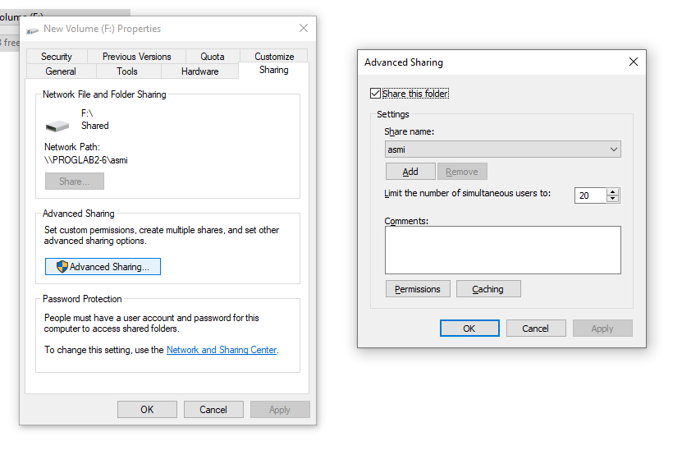

Step2

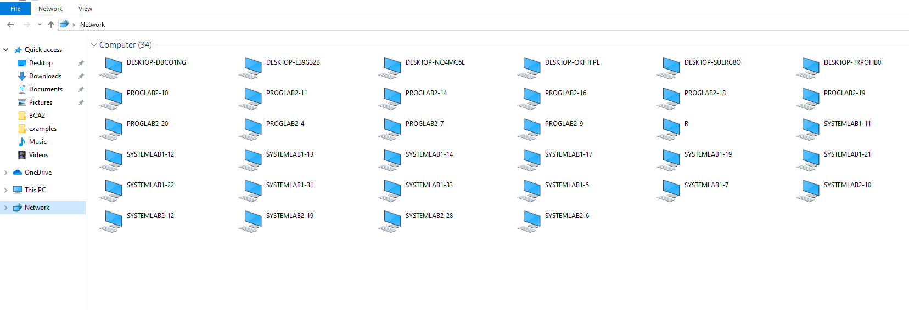

Step3

